**NOUMAN AHMAD  
#3271**

**Fuzzy Logic-Based Financial Forecasting: Develop a financial forecasting model using fuzzy logic to predict stock prices, currency exchange rates, or market trends. The model can consider various economic indicators and historical data to provide forecasts**

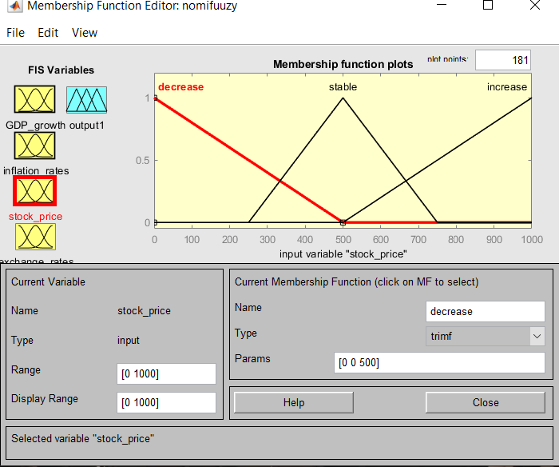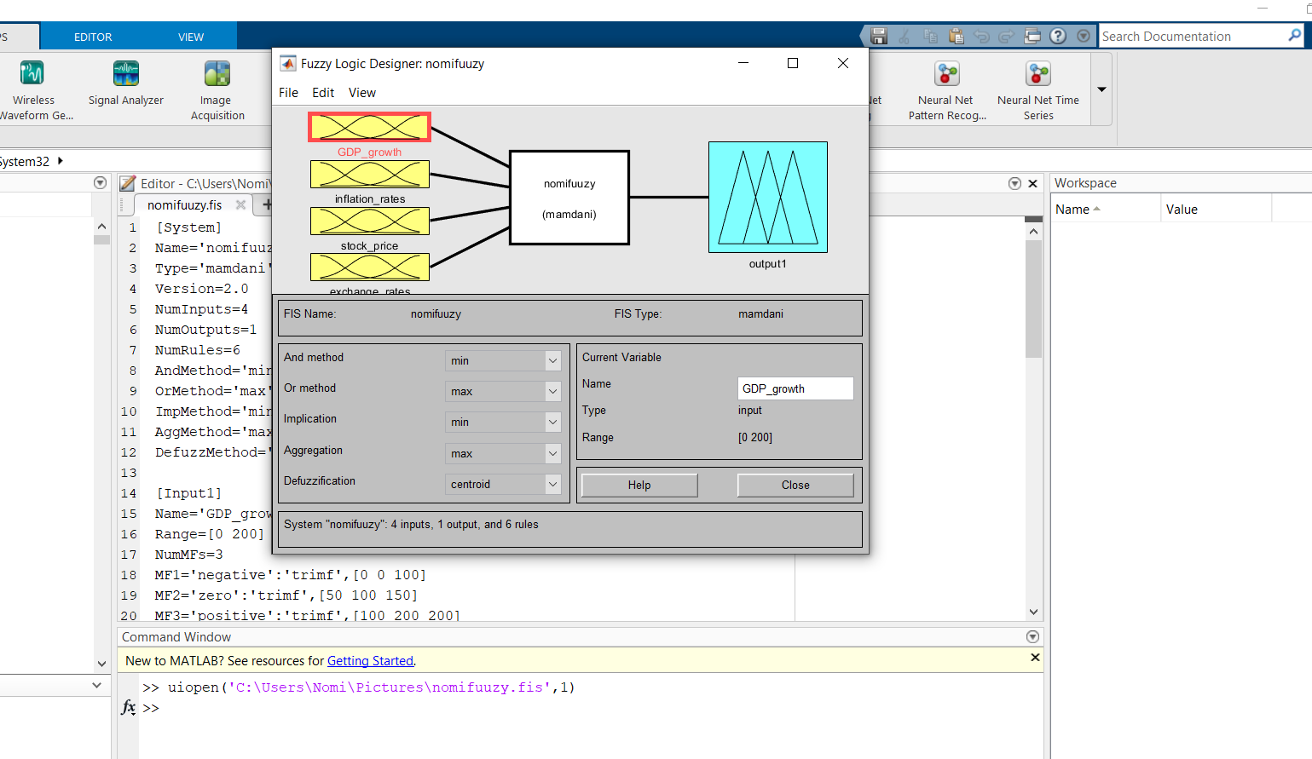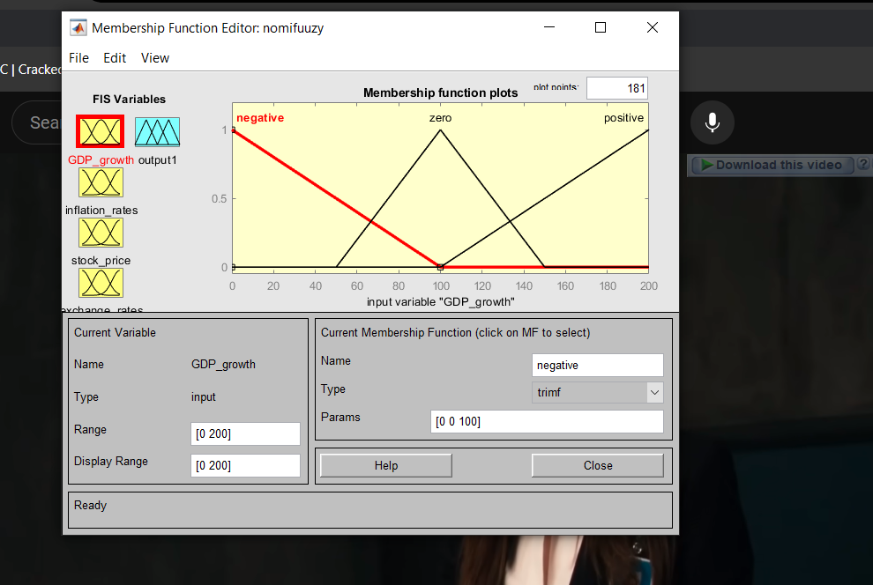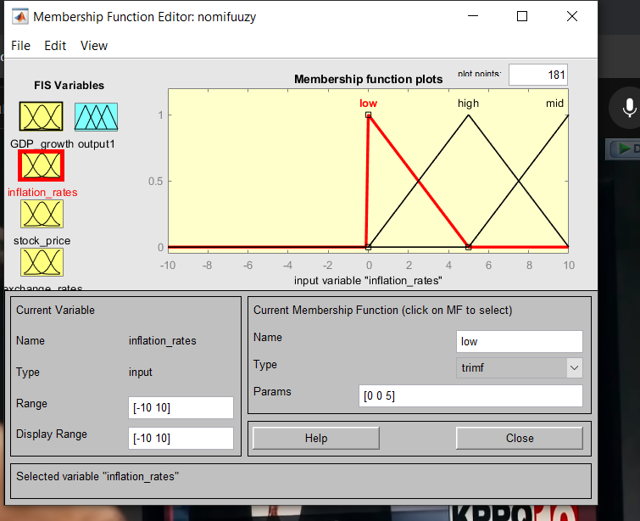

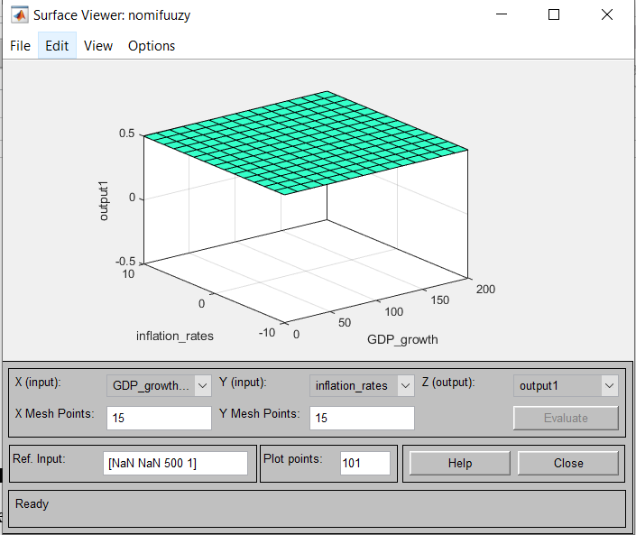

### Step 1: Define the Problem and Collect Data

### Select the Forecasting Target:

Decide whether you want to predict stock prices, currency exchange rates, or market trends.

### Collect Data:

Gather historical data for the target variable.

Collect economic indicators (e.g., interest rates, GDP growth, inflation rates).

Obtain market data (e.g., stock indices, commodity prices, trading volumes).

### Step 2: Preprocess the Data

### Data Cleaning:

Handle missing values, outliers, and inconsistencies in the data.

### Normalization:

Normalize the data to bring all variables to a comparable scale, typically between 0 and 1.

### Step 3: Define Fuzzy Variables

### Identify Input Variables:

Select relevant economic indicators and historical data points as input variables.

### Create Fuzzy Sets:

Define fuzzy sets for each input variable. For example, if an input variable is "interest rate," fuzzy sets might include "low," "medium," and "high."

### Membership Functions:

Design membership functions for each fuzzy set. Common shapes include triangular, trapezoidal, and Gaussian functions.

### Step 4: Develop Fuzzy Rules

### Rule Base:

Compile all fuzzy rules into a rule base.

### Step 5: Implement Fuzzy Inference System

### Fuzzification:

Convert crisp input values into fuzzy values using the membership functions.

### Inference:

Apply the fuzzy rules to the fuzzified inputs to generate fuzzy output values.

### Defuzzification:

Convert the fuzzy output values back into crisp values. Common defuzzification methods include the centroid method and the max membership principle.

### Step 7: Deployment and Continuous Improvement

### Deploy the Model:

Implement the model for real-time forecasting.

### Monitor Performance:

Continuously monitor the model's performance and update the fuzzy rules and membership functions as needed to adapt to changing market conditions.

### Example Implementation

Here's a basic example using Python's **skfuzzy** library to illustrate the process:

# Define fuzzy variables

interest_rate = ctrl.Antecedent(np.arange(0, 10, 0.1), 'interest_rate')

gdp_growth = ctrl.Antecedent(np.arange(-10, 10, 0.1), 'gdp_growth')

stock_price = ctrl.Consequent(np.arange(0, 1000, 1), 'stock_price')

# Define membership functions

interest_rate['low'] = fuzz.trimf(interest_rate.universe, [0, 0, 5])

interest_rate['medium'] = fuzz.trimf(interest_rate.universe, [0, 5, 10])

interest_rate['high'] = fuzz.trimf(interest_rate.universe, [5, 10, 10])

gdp_growth['negative'] = fuzz.trimf(gdp_growth.universe, [-10, -10, 0])

gdp_growth['zero'] = fuzz.trimf(gdp_growth.universe, [-5, 0, 5])

gdp_growth['positive'] = fuzz.trimf(gdp_growth.universe, [0, 10, 10])

stock_price['decrease'] = fuzz.trimf(stock_price.universe, [0, 0, 500])

stock_price['stable'] = fuzz.trimf(stock_price.universe, [250, 500, 750])

stock_price['increase'] = fuzz.trimf(stock_price.universe, [500, 1000, 1000])

# Define fuzzy rules

rule1 = ctrl.Rule(interest_rate['low'] & gdp_growth['positive'], stock_price['increase'])

rule2 = ctrl.Rule(interest_rate['high'] & gdp_growth['negative'], stock_price['decrease'])

rule3 = ctrl.Rule(interest_rate['medium'] & gdp_growth['zero'], stock_price['stable'])

# Create control system

stock_price_ctrl = ctrl.ControlSystem([rule1, rule2, rule3])

stock_price_sim = ctrl.ControlSystemSimulation(stock_price_ctrl)

# Provide input values

stock_price_sim.input['interest_rate'] = 3

stock_price_sim.input['gdp_growth'] = 4

# Perform inference

stock_price_sim.compute()

# Get output value

forecasted_stock_price = stock_price_sim.output['stock_price']

print(f"Forecasted Stock Price: {forecasted_stock_price}")

Developing a fuzzy logic-based financial forecasting model involves defining fuzzy sets and rules that reflect the relationships between various economic indicators and the target financial variable. By continuously monitoring and refining the model, it can provide valuable predictions for decision-making in uncertain and dynamic market environments.